**CSS 335 Data Communications and Network I**

**Homework 2**

1. Sketch the signals corresponding to the following bit stream: 01000110 assuming a symbol duration *T* = 1s:
   1. Unipolar RZ signals

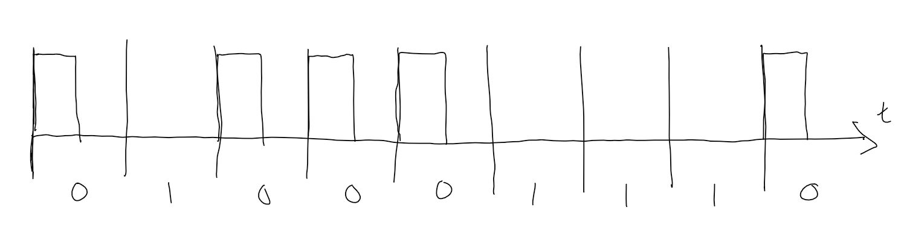

* 1. Antipodal NRZ signals

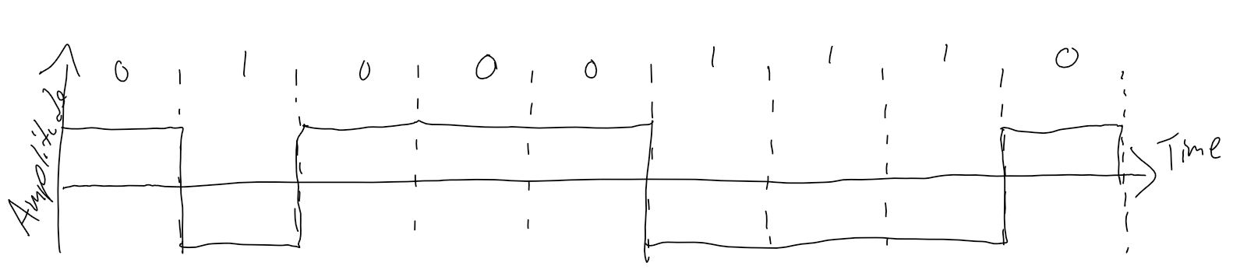

* 1. Manchester encoding

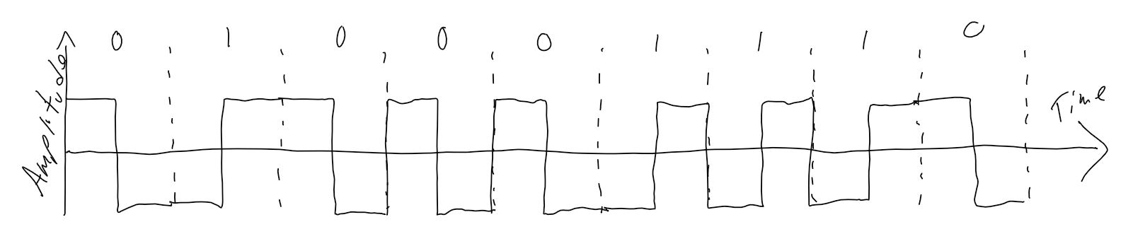

1. Is the signal *x*(*t*) = cos2(2π*ft*) periodic? Why? Attach your plot.

Yes, it is periodic. It has a period of .05, so every .05 a full wave has been completed.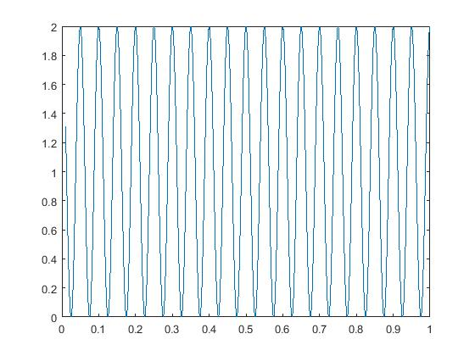

1. Use Matlab or R to plot a periodic signal made of several sinusoids given by:

*x*(*t*) = -0.3 + 0.1 cos (20π*t*) + 0.5 cos(40π*t* + π/5) + 0.7cos(60π*t* + π/8) + 0.2 cos(80π*t* + π/3). Use an appropriate time scale. Attach your plot.

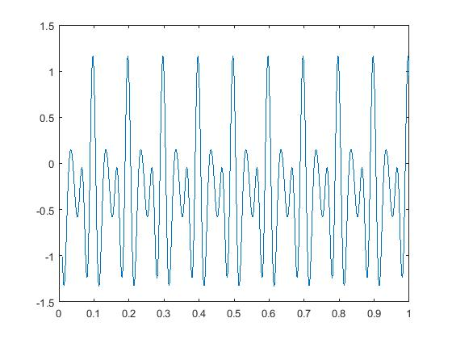

1. Let us suppose that you have an analog signal that needs conversion to digital. The maximum frequency component in the signal is 2 kHz.
   1. At what minimum rate should you sample the signal (i.e., at least how many samples per second do you need)?

4kHz

* 1. If you are quantizing the signal into 16 levels, how many bits do you need per sample?

4 bits.

* 1. What is the data rate of the digital signal after quantization with 16 levels? What is the data rate after quantization with 32 levels?

16 levels : 16 kbps

32 levels : 20 kbps

1. Consider the signal received by a laptop from a WLAN access point.
   1. If the WLAN access point operates at a power level of .032 watts, what is the signal strength in dBm?

2.505 dBm

* 1. The loss in the signal strength due to the first meter and the distance between the access point and the laptop is 80 dB. What is the received power or received signal strength?

-82.5 dB

* 1. If the noise power at the laptop is -86 dBm, what is the SNR in dB?

- 0.18 dB

1. Consider a cellular phone network that uses a channel with bandwidth of 200 kHz and operates at an SNR of 9 dB. What is the capacity of the channel?

0.405 kbps

1. Signals travel at a speed of 2/3 the speed of light on an unshielded twisted pair cable. If the cable length is 2 km, what is the propagation delay?

0.00001 seconds.

1. If the raw data rate on an unshielded twisted pair cable is 10 Mbps, what is the transmission delay for one bit? What is the transmission delay for an Ethernet frame of size 1500 bytes?

One bit: 0.0000001 seconds

1500 bytes: 0.0012 seconds